Title (Heading 1: Arial 18pt)

Author’s Last Name, Author’s First Name*a; Second Author’s Last Name, Second Author’s First Nameb; Third Author’s Last Name, Third Author’s First Nameb (Authors: Calibri 10pt)

a Affiliation Organisation Name, City, Country (Affiliation: Calibri 9pt)

b Affiliation Organisation Name, City, Country

* The corresponding author e-mail address

This guide offers precise directions for submitting a workshop proposal for the ICADT 2024 congress, which will be held by the Department of Creative Arts at Hong Kong Metropolitan University. Kindly adhere to the precise formatting of this document when submitting your workshop proposal. To expedite the process of formatting your contribution, you can replace the content of this template with your own. To locate the text styling of this template, simply search for the embedded styles that have the term 'ICADT' in their names. The workshop proposal should have a word count of 1500-2000, not including the abstract and references. The abstract should have a maximum of 250 words and should not include any quotations or references. Send the workshop proposal to icadt2024@outlook.com for evaluation. (Abstract: Calibri 10pt)

Keywords: formatting instruction; template; workshop; ICADT (maximum 4 keywords, separate each keyword with a semicolon) (Keywords: Calibri bold italic 10pt)

1. Workshop description (Heading 2: Calibri bold 14pt)

The ICADT 2024 workshops offer participants the chance to establish connections and bridges between research and practice, as well as explore various subjects and concerns. We welcome submissions that delve into concepts, theories, processes, frameworks, practices, and pragmatics within the four themes, using a lengthy format of 3 hours for each session.

Prospective applicants desiring to present a workshop proposal are required to compose a proposal of 1500-2000 words, eliminating the references. The workshop proposal must adhere to this template and incorporate the following elements: a comprehensive overview of the topic, a clear thematic connection, a defined workshop objective, a description of the methods to be applied, an anticipated outcome, and a bio section at the end of the template highlighting the prior expertise of each workshop organiser. Please provide a concise workshop programme and details regarding the expected participant profile and numbers.

Workshop proposals will not be included in the proceedings, but they will be published on the conference website prior to its commencement. The workshop entries will be reviewed and selected by review panels from the Conference committee. Following the evaluation time, we will inform all authors of the outcome of their submission, either accepting or rejecting it, through email.

Following the completion of the workshop, it is necessary for the workshop organizer(s) to provide a comprehensive report detailing the outcomes, which should also include images taken during the workshop. The study will be published on the ICADT website.

Provide a concise overview of the subject's background, its connection to one of the congress' nine sub-themes, and the objective of the workshop.

1. Session set-up

This section should provide a thorough explanation of the proposed format and activities, including a detailed plan and timetable, the anticipated participant profile and numbers, the technique for documenting contributions, and the intended outcomes. This section can be structured using tables and/or paragraphs and may use graphics or diagrams (see to section 4 for instructions on formatting). Lastly, elucidate the distinct functions fulfilled by the organisers.

1. Requirements

Kindly enumerate the primary prerequisites of your proposition. Specify the necessary requirements for a productive session, including the type of space and providing a detailed list of specific items such as tables, chairs, supplies, laptops, projectors, and so on. We will furnish places and supplies, but we kindly ask authors to specify their individual needs.

1. Formatting your workshop submission

In order to save time on structuring your contribution, you can replace the content of this template with your own. To locate the text styling of this document, simply search for the embedded styles in the Styles Pane that include the term 'ICADT' in their names.

The page dimensions are set to A4 size, which is 21cm x 29.7cm. The top, bottom, left, and right margins are all set to 2.5 cm.

Kindly utilise footnotes in lieu of endnotes and refrain from employing footnotes as a compilation of references.

* 1. Headings (Heading 3: Calibri bold 12pt)

You can find the Heading styles of this document under the names ‘ICADT Heading 1’, ‘ICADT Heading 2’, ‘ICADT Heading 3’, and ‘ICADT Subheading’. Always add text below the headings (never leave headings under headings).

* + 1. Subheadings (Subheading: Calibri 11pt)

To add an additional heading level, using the 'ICADT Subheading' style. This subheading style shares the same formatting as the main text of the document, specifically the 'ICADT Main text' style.

* 1. Title and authors

The titles of workshop proposals should be limited to a maximum of two rows in length. The workshop organisers should be credited as the authors of the workshop proposal.

* 1. Language and style

The conference use English as its written language. When composing text, endeavour to employ gender-neutral language and refrain from utilising complex technical terminology. Prior to utilising acronyms for the initial occasion, it is necessary to write out the complete name.

* 1. Lists

To create a sequential list with numbers, utilise the 'ICADT Numbered List' style. As example:

1. List item 1 (Numbered list: Calibri 11pt)
2. List item 2
3. List item 3

To create non-sequential listings using bullet points, utilise the 'ICADT Bullet List' style. As example:

* Bullet point 1 (Bullet list: Calibri 11pt)
* Bullet point 2
* Bullet point 3
  1. Images

Images and figures should have a resolution that is suitable for both printing and viewing online. We suggest using a resolution of 300 pixels per inch (ppi) and a minimum resolution of 150 ppi. Ensure that images or figures are consistently positioned within the main body of the text and that the captions are formatted using the 'ICADT Caption' style. It is important to ensure that images/figures and their captions are consistently aligned with the left margin and do not exceed the width of the column. Assign sequential numbers to the images/figures, beginning with Figure 1. Refer to Figure 1 for an illustrative case.



Figure 1. IOH campus of the Hong Kong Metropolitan University. Source: HKMU. (Caption: Calibri italic 9pt)

The captions accompanying the figures should provide a clear and concise explanation of the visual content in relation to the accompanying text. If there are many photographs positioned next to each other, as depicted in Figure 2, it is advisable to merge the figures into a solitary image using image editing software such as Adobe Photoshop, prior to inserting them into the text.

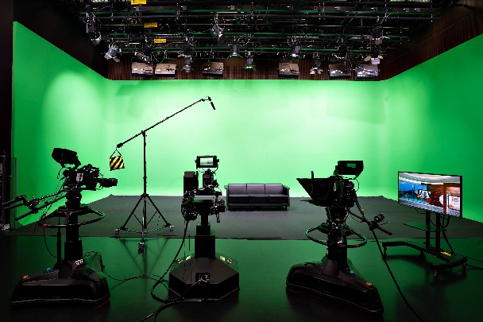 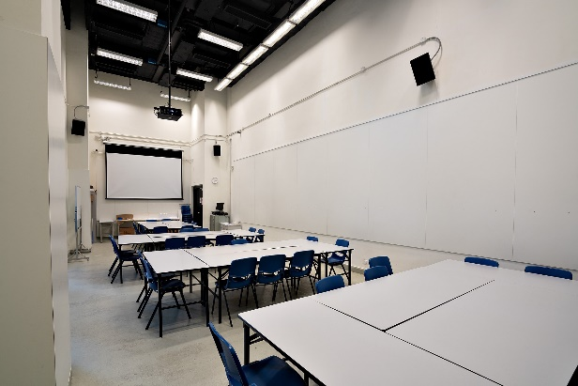

Figure 2. Creative Arts Studios at the Department of Creative Arts of Hong Kong Metropolitan University.   
Source: Department of Creative Arts.

We welcome the authors to use colour images.

* 1. Tables

Utilise Word's table functionality to generate tables and apply formatting to designate them as Table 1. Wherever feasible, align the text of all columns to the left. Assign consecutive numbers to tables, commencing with Table 1.

See Table 1 for an example.

|  |  |  |  |
| --- | --- | --- | --- |
| (Table text: Calibri 10pt) | **Column 2** | **Column 3** | **Column 4** |
| **2nd Row** | Cell one | Cell four | Cell seven |
| **3rd Row** | Cell two | Cell five | Cell eight |
| **4th Row** | Cell three | Cell six | Cell nine |

Table 1. This is an example of a table that adapts from an external source

If the table is sourced externally, identify the original reference below the table using the 'ICADT Caption'. If the table is an original work, enter one empty line below the table using the 'ICADT Caption', as demonstrated in Table 2.

Table 2. This is an example of the formatting of an original table (Table title: Calibri 10pt)

|  |  |  |  |
| --- | --- | --- | --- |
| (Table text: Calibri 10pt) | **Column 2** | **Column 3** | **Column 4** |
| **2nd Row** | Cell one | Cell four | Cell seven |
| **3rd Row** | Cell two | Cell five | Cell eight |
| **4th Row** | Cell three | Cell six | Cell nine |

* 1. Referencing

Kindly adhere to the **APA reference format** when preparing the workshop proposal. To obtain additional information, please consult lessons 16-19 of the book ‘Basics of 7th Edition APA Style.’ To format the reference list, utilise the 'ICADT Reference' style. Whenever feasible, incorporate the Digital Object Identifier (DOI).

Enclose citations that are not part of a sentence within brackets. **For instance:** (Jackson, 2019). Include the author's name in the text and enclose the year in brackets for citations that are integrated into a sentence. **As an illustration**, Jackson (2019) contends that...

When referencing numerous books by the same author(s), use commas to separate the publication years. When referencing multiple works by different authors within a single parenthesis, use semicolons to separate them and arrange them in alphabetical order. **As an illustration**, the sources cited are Dillard (2020) and Jackson (2019).

Provide the full names of one or two authors when citing a reference. As an illustration, the work by Kushilevitz and Malkin in 2016 serves as an example. When there are three or more authors, only the first author's name should be mentioned, followed by ‘et al.’. **As an illustration**, Duckworth et al. (2019) provide an example.

References

Examples of references (taken from [APA Style](https://apastyle.apa.org/style-grammar-guidelines/references/examples)):

Journal article with a DOI:

Grady, J. S., Her, M., Moreno, G., Perez, C., & Yelinek, J. (2019). Emotions in storybooks: A comparison of storybooks that represent ethnic and racial groups in the United States. *Psychology of Popular Media Culture, 8*(3), 207–217. https://doi.org/10.1037/ppm0000185 (Reference list: Calibri 10pt)

Conference proceedings published in a journal:

Duckworth, A. L., Quirk, A., Gallop, R., Hoyle, R. H., Kelly, D. R., & Matthews, M. D. (2019). Cognitive and noncognitive predictors of success. Proceedings of the National Academy of Sciences, USA, 116(47), 23499–23504. https://doi.org/10.1073/pnas.1910510116

Conference proceedings published as a whole book:

Kushilevitz, E., & Malkin, T. (Eds.). (2016). *Lecture notes in computer science: Vol. 9562. Theory of cryptography.* Springer. https://doi.org/10.1007/978-3-662-49096-9

Conference proceedings published as a book chapter:

Bedenel, A.-L., Jourdan, L., & Biernacki, C. (2019). Probability estimation by an adapted genetic algorithm in web insurance. In R. Battiti, M. Brunato, I. Kotsireas, & P. Pardalos (Eds.), *Lecture notes in computer science: Vol. 11353. Learning and intelligent optimization* (pp. 225–240). Springer. https://doi.org/10.1007/978-3-030-05348-2_21

Book:

Jackson, L. M. (2019). *The psychology of prejudice: From attitudes to social action* (2nd ed.). American Psychological Association. https://doi.org/10.1037/0000168-000

Sapolsky, R. M. (2017). *Behave: The biology of humans at our best and worst*. Penguin Books.

Svendsen, S., & Løber, L. (2020). *The big picture/Academic writing: The one-hour guide* (3rd digital ed.). Hans Reitzel Forlag. https://thebigpicture-academicwriting.digi.hansreitzel.dk/

Chapter in a book:

Aron, L., Botella, M., & Lubart, T. (2019). Culinary arts: Talent and their development. In R. F. Subotnik, P. Olszewski-Kubilius, & F. C. Worrell (Eds.), *The psychology of high performance: Developing human potential into domain-specific talent* (pp. 345–359). American Psychological Association. https://doi.org/10.1037/0000120-016

Dillard, J. P. (2020). Currents in the study of persuasion. In M. B. Oliver, A. A. Raney, & J. Bryant (Eds.), *Media effects: Advances in theory and research* (4th ed., pp. 115–129). Routledge.

Thestrup, K. (2010). To transform, to communicate, to play—The experimenting community in action. In E. Hygum & P. M. Pedersen (Eds.), *Early childhood education: Values and practices in Denmark*. Hans Reitzels Forlag. https://earlychildhoodeducation.digi.hansreitzel.dk/?id=192

About the Authors: (Author bio title: Calibri bold 10pt)

**Organiser’s name:** Describe the prior experience of the workshop organiser in a maximum limit of 50 words. (Author bio text: Calibri 10pt)

**Organiser’s name:** Describe the prior experience of the workshop organiser in a maximum limit of 50 words.

**Organiser’s name:** Describe the prior experience of the workshop organiser in a maximum limit of 50 words.